North American
Disease Spread Simulation Model

User’s Guide

Draft 1
February 1, 2005
Purpose and uses of the program 4
Capabilities 4
Limitations 5
Basics of stochastic modeling 6
System requirements and installation 8
Getting started 8
Navigation 9
File menu 9
New scenario 9
Open scenario 9
Save scenario 10
Save as 10
Tools 10
Exit 10
Setup/Parameters menu 10
Start setup 10
Output settings 11
Production type(s) 11
Setup starting units 11
Disease 13
Surveillance 14
Vaccination 16
Destruction 18
Economics/cost 20
Spread 22
Interactive/advanced 25
View current units 27
Run menu 27
Start or restart simulation run 27
Continue current simulation run 28
Stop simulation 28
Output/Windows menu 28
Map of units 28
Charted status of units 29
Outbreak statistics 29
Cost of outbreak 30
Contact-exposure events 30
Apparent outbreak events 31
Summary information 32
Help menu 34
Creating, modifying and exporting a probability density function 34
Importing a pdf 35
Creating a new pdf 35
Using a known probability function 35
Creating your own shape 36
Exporting a pdf 37
Printing a pdf 38
Creating, modifying, and exporting a function (relationship) 38
Importing a relationship 38
Creating a new relationship 38
Changing the x- and y-axes 38
Adding a new point 39
Moving an existing point 39
Deleting an existing point 39
Edit all points 39
Exporting a relationship 39
Printing a relationship 40
Structure (conceptual framework) 40
Basics 40
Disease 41
Spread 41
Direct contact spread 41
Indirect contact spread 44
Airborne spread 44
Detection 45
Control measures 46
Quarantine 46
Destruction 46
Vaccination 48
Vaccine 49
Priorities of action 49

Purpose and uses of the program
SpreadModel simulates outbreaks of foot and mouth disease. As a training tool, SpreadModel can be used to prepare emergency personnel and other first responders for disease outbreaks. SpreadModel can also be used to demonstrate to policy makers the potential scope and impact of an outbreak in their region. As a research tool, SpreadModel can be used to compare disease control strategies and estimate the resources needed in the event of an outbreak.
We do not recommend that SpreadModel be used during an outbreak to predict direction and magnitude of disease spread, or be used during an outbreak as the basis for policy decisions. Information on disease incidence early in an outbreak is typically inaccurate. Simulated outbreaks based on inaccurate information will be useless, and may provide a false sense of security regarding the scope and control of the outbreak.

Capabilities
General. SpreadModel is a flexible tool for temporally and spatially simulating the spread of foot and mouth disease at the herd level in a population of naïve animals. Users can input their own animal population data and adjust all animal population, disease transmission, and disease control parameters to closely mimic the situation in their region, can use the provided animal data and parameters, which mimic the American Midwest, or can create their own randomly-distributed animal population data.
Animal populations. Herds can be sub-classified by user-defined production types. A production type groups herds with similar disease transmission probabilities, disease manifestation, disease detection probabilities, and control strategy. The user defines the probability of airborne transmission and the rates of contact within and between production types to better mimic disease spread. Production types can be broad (e.g. cattle, swine, poultry) or narrow (e.g. Beef sale yard, beef cow-calf operation <50 head, beef cow-calf operation >50 head, beef feedlot). SpreadModel can incorporate up to 99 user-defined production types.
Disease manifestation. SpreadModel categorizes each herd as susceptible, latently infected, infectious and subclinically ill, infectious and clinically ill, and immune. For each production type, the user defines the length of these periods (in days) using probability distributions. All animals in a herd are assumed to exist in the same disease state.
Disease transmission. SpreadModel was designed to simulate foot and mouth disease, but can be used to simulate any contagious animal disease that is spread primarily through aerosol transmission and/or direct and indirect contact. User-defined parameters define the probabilities of transmission via each method between and within production types.
Disease detection and surveillance. SpreadModel allows the user to simulate both passive and active disease surveillance. For each herd, passive surveillance is a function of the length of time since the outbreak began, and the length of time the herd has been infected. Active surveillance targets contacts from infected herds, and herds within a specified distance of infected herds.
Disease control. SpreadModel simulates three methods of disease control: ring vaccination, movement restrictions, and depopulation. Within production type, the user defines the conditions under which these measures are adopted, time to and length of vaccine-induced immunity, and the number of herds that can be vaccinated or depopulated per day. Vaccination is assumed to be 100% effective.
Direct costs. SpreadModel can estimate the direct costs associated with each simulated outbreak. User inputs include itemized costs associated with disease surveillance, vaccination, depopulation, and trade restrictions.
Output: SpreadModel generates a daily summary of each outbreak simulated, an epidemic curve, a breakdown of costs associated with the outbreak, and hundreds of individual statistics (days to end of outbreak, number of herds and animals infected, number of herds and animals vaccinated, etc.). When the same simulation is run multiple times, SpreadModel summarizes the results over all iterations using histograms, measures of central tendency and spread, and graphical depiction of convergence. SpreadModel can also export output in GIS format.
Computational issues. SpreadModel is available for PC, Mac, Unix, and supercomputer platforms. The PC version can be run on a stand-alone machine, or on a cluster of networked PCs using Atriplex distributed computing software. An average stand-alone PC can comfortably simulate disease spread among ??? herds. Simulations involving more than ??? herds are better run on the supercomputer or networked PC versions of SpreadModel.
Parameter development is best performed using the PC version of SpreadModel. Once parameters have been defined, they can be exported to the Mac, Unix, or Supercomputer versions of the program.

Limitations
Diseases. SpreadModel is not capable of simulating chronic, endemic, fatal, vertically-transmitted, sexually-transmitted, or vector-borne diseases, diseases with environmental or biologically-adapted reservoirs, or diseases that do not confer post-infection immunity.
Uses. As mentioned previously under “Purpose and uses of the program,” SpreadModel is not intended to be used in the face of an outbreak to predict magnitude or direction of disease spread.

Basics of stochastic modeling
Biological processes display inherent variability. Take height, for example: height for human males can range from 5 to 7 feet (1.5 to 2.1 meters), although the average is close to 5 feet, 9 inches (1.77 meters) in the United States. If you were to develop a computer model for something (say, to predict the amount of cloth needed to make some number of pairs of pants), and you needed to include human male height as a variable, you could do this in two ways. The first way would incorporate height as a single value, i.e. 5 feet 9 inches, and assume that all men are that height. This is called deterministic modeling, because the value of the variable height has already been determined. The second way would be to incorporate height as a distribution (see Figure 1, below), and draw a value from the distribution each time the model is run. Values with higher probability of occurring (i.e. heights close to 5’9”) are more likely to be drawn than values at the extreme ends (“tails”) of the distribution. This is called stochastic modeling (stochastic = “being or having a random variable”) because height is not a fixed value, it is a random variable drawn from a distribution. In Figure 1, we can see that values below 1.61 meters (5’3”) are drawn 5% of the time, and values above 1.93 meters (6’4”) are drawn 5% of the time. Thus, 90% of the time, the value of height will be between 5’3” and 6’4” (1.61 and 1.93 meters).
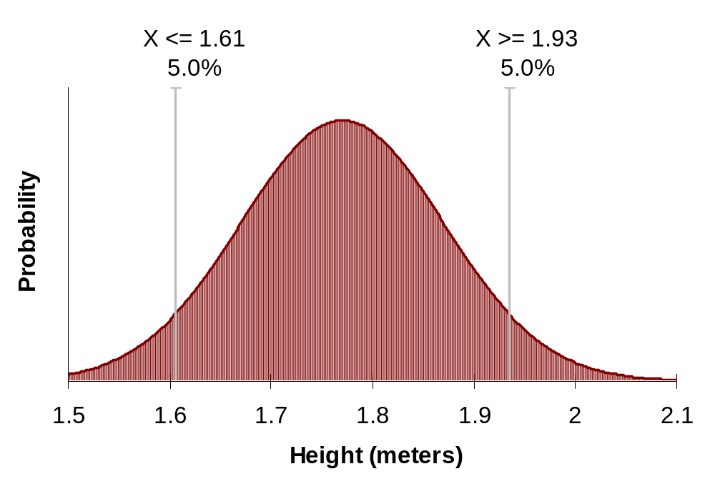
Figure 1. Distribution of height among males in the United States
For stochastic models, both the inputs and the outputs are distributions. As an example, consider a model with two variables: height and amount of fabric (per inch of height) needed to make a pair of pants. In a deterministic model, your variables would have fixed values (5’9” and 0.05 yards of fabric per inch). If you wanted to estimate the amount of fabric needed to make 1000 pairs of pants, you would run the model once to calculate the amount of fabric needed for one pair of pants, then multiply the results by 1000. Running the model additional times would not provide any new information. In a stochastic model, your variables are drawn from distributions to account for variability in height, and variability in fabric used per inch of height (affected by obesity and pants style). Running the stochastic model once is not particularly informative. However, by running the model 1000 times (“iterations”), you get 1000 different estimates of the fabric needed for one pair of pants. These estimates form a distribution (Figure 2). To estimate the fabric needed for 1000 pairs of pants, you sum the 1000 estimates.
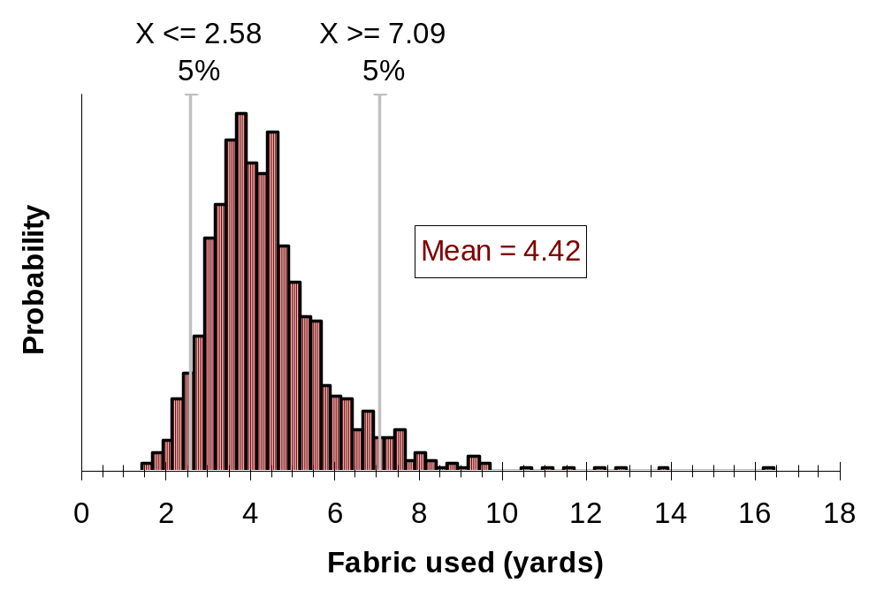
Figure 2. Output of 1000 iterations of a stochastic model estimating the amount of fabric needed to make a pair of pants.
Results of stochastic models incorporate variability, whereas results from deterministic models do not.
SpreadModel is a stochastic model. Variability is incorporated in the model using two methods: distributions, and relationships, both of which are user-defined. A distribution is used when the variability in a parameter is assumed to be random. The distribution describes the range of values a variable can take, and how likely those values are to be selected. Model parameters described as distributions include length of infectious period, and distance that an animal is likely to be transported. A relationship is used when the variability in one parameter is due to another factor. A relationship describes one variable as a function of another (Figure 3). Model parameters described as relationships include the probability of detecting an infectious herd (a function of time since the herd was infected), and number of herds that can be depopulated per day (a function of time since the outbreak was detected).
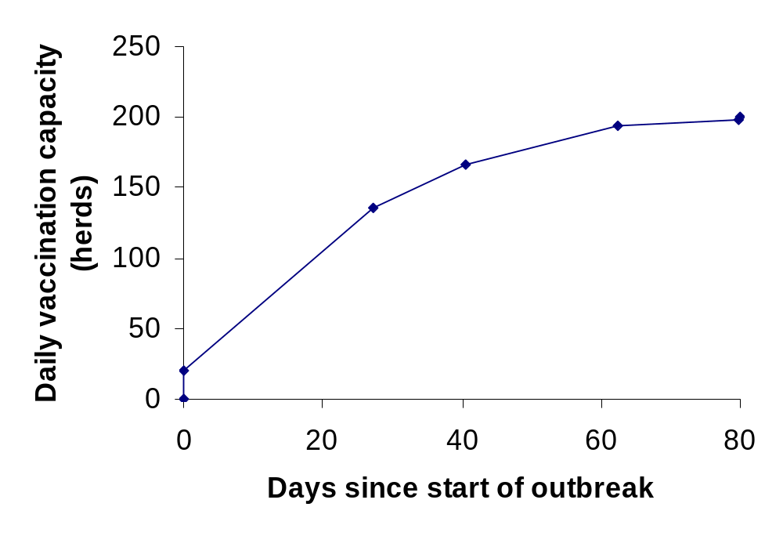
Figure 3. Number of herds that can be vaccinated per day as a function of time since the start of an outbreak.

System requirements and installation
Installing SpreadModel on a PC. SpreadModel requires Windows 95 (???) or greater, 128 MB of RAM, (?? SpreadModel used a max of 110 MB RAM when I ran it; not sure how much Win95 system takes) and a minimum of 50 MB of available hard disk space. Register and download SpreadModel from our web site (whatever.whatever.whatever). Double-click on the installation wizard and follow directions to install SpreadModel on your machine.
Installing SpreadModel on a unix-based system. SpreadModel can be used on any unix-based system, including Macintosh OS X and higher, and Linux. SpreadModel Unix requires … ????.

Getting started
After opening SpreadModel.exe, go to the File menu, choose Open Scenario, and select the file Example.mdb, which should be located in the same directory as SpreadModel.exe. You should now see a map of herds, with latitude and longitude coordinates, on your screen. Example.mdb contains a scenario with animal population and parameter data representative of the American Midwest.
To review the parameters for this scenario, go to the Setup/Parameters menu and choose Start Setup. In the Number of Iterations box, type 1. From the Random Values pull-down menu, select Generated during run to ensure the model runs stochastically. Click the Finish button when you are done reviewing the model parameters.
To start the simulation, go to the Run menu, choose Start or restart simulation run, and select Stopping at the end of outbreak(s). SpreadModel will now run the simulation. On the map, the dots representing herds will change colors to indicate what disease stage they are in. Clicking on the Status button on the map will change the legend to show disease status from an emergency personnel standpoint. At the bottom of your screen, a counter tracks the iteration number, and the day of the outbreak. A single run (iteration) of this scenario can take a long time (~1 hour, depending on computer speed) to reach completion. If you want to stop the iteration prematurely, click on the Stop button in the lower right corner of your screen. SpreadModel will finish simulating the current “day” and then stop.
After the simulation has stopped (or been stopped), go to the Output/Windows menu and choose Summary Information. This window summarizes the number of herds and animals detected as diseased, diseased but not detected, destroyed, and vaccinated. Additionally, you can see the epidemic curve apparent to emergency management personnel, as well as the “true” epidemic curve including undetected diseased herds.

Navigation

File menu
The file menu includes tools for managing database (scenario) files, as well as the means to create, open, and save files. Scenario files are in MS Access format. These files store all information about a scenario: the geolocation, number of animals, and production type of each herd, the disease spread and control parameters for each production type, and all output from simulating the scenario.
New scenario
This option creates an empty scenario file. The user must enter all disease and control parameter values, and must import or create an animal population to which these parameters apply.
Open scenario
Opens an existing scenario file.
Save scenario
Saves the current scenario.
Save as
Saves the current scenario under a different name. Parameterizing and populating a scenario from scratch is time-consuming. In most cases, it is more efficient to open an existing scenario, then alter parameters as necessary and save the scenario under a different name.
Tools
Repair/compact database. MS Access files increase in size each time they are used. This increase in size, though it is mostly empty space, can slow down the operation of SpreadModel. Every 2-3 times you use a scenario, we suggest compacting the database. This will streamline SpreadModel operation, as well as minimize space used on your hard drive.
SQL tool. This tool for advanced users enables use of SQL (structured query language).
Append output. Not currently implemented. This will allow (I think!) output from a new series of iterations to be added to, rather than replace, output from previous iterations using the same scenario.
Remove temporary files. (not sure about this!) If your computer crashes or is shut down in the midst of a simulation, temporary files created during the simulation will remain on your computer. Use this option to remove those files.
Exit
Shuts down SpreadModel.

Setup/Parameters menu
Options in this menu allow you to create or modify an animal population, specify parameters for disease spread and control, select optional output data, and enter costs associated with disease and disease control. After selecting Start setup, clicking on the Next button will take you through all basic setup options. Alternatively, you can select setup options individually from the menu.
Start setup
In this window, you enter a text description of your scenario, specify the number of times you want to run the scenario, and select whether you want the model to run stochastically or deterministically.
Number of iterations establishes how many times you want to run the scenario. The more iterations you run, the better distribution of results you obtain. You can then better determine which results occur commonly, and which are unusual. The current standard in stochastic modeling is 100 – 10,000 iterations, though that range may be impractical for large or complex data sets. Ten iterations may be a good starting point.
Random values specifies whether SpreadModel runs stochastically or deterministically. For stochastic modeling, select Generated during run. For deterministic modeling, select Use a fixed value, then enter a number between 0 and 1 in the Fixed value box. The fixed value you enter specifies which value will be chosen from each distribution. For example, if your fixed value is 0.5, SpreadModel will select the median value (50th percentile) from each distribution it uses, whereas if your fixed value is 0.75, SpreadModel will select the value at the 75th percentile.
Output settings
You can select additional SpreadModel outputs here. Requesting additional output will slow the operation of SpreadModel.
Events by day creates a dataset including … (not sure what this does).
GIS output. When this option is selected, SpreadModel will create spatial output datasets readable by GIS (graphical information systems) software. Under Export dataset to GIS system, choose how frequently (during the simulated outbreak) GIS data should be output, keeping in mind that each export uses computational resources. Your selection of File format will depend on the import options available in your GIS software. Use the Browse button to select the location and filename of your GIS export file.
Production type(s)
Use this window to create (Add), rename (Modify), or Remove production types, which are groups of herds. A production type defines a group of herds with similar disease transmission probabilities, disease manifestation, disease detection probabilities, and control strategy. Production types can be broad (e.g. cattle, swine, poultry) or narrow (e.g. Beef sale yard, beef cow-calf operation <50 head, beef cow-calf operation >50 head, beef feedlot). SpreadModel can incorporate up to 99 user-defined production types. All herds must have a production type.
Setup starting units
Use this section to import, create, or edit your animal population data.
Add units randomly positioned in a circle. Select this option if you have no animal population data, or if you want to add herds to your existing population. Click on the Next button to generate animal population data.
Definition of main circle for location of added units allows you to specify the geolocation (Latitude and Longitude) and Radius of your circle. If adding to an existing population, the latitude and longitude should be within your existing region. Latitude values range from -90 to +90, whereas longitude values range from -180 to +180 degrees. Proportion of units should be 1, unless you also want to create clusters of herds within your circle.
Randomly distributed clusters of smaller circles within the main circle. This option allows you to include multiple smaller clusters of herds within your circle. All clusters will be the same size if more than one is included. These may mimic dense unit areas within a general population. To activate this option, enter a value less than 1 for Proportion of units under Definition of main circle. The total proportion of units for the main circle and the randomly distributed clusters will add up to 1. Specify the size (Radius) and Number of clusters to include. Clusters are smaller circles that will be randomly distributed within the general circle.
Use the Production type table to specify herd size ranges for each production type, as well as the relative proportions for each production type. For each production type, enter the percentage of herds (Proportion) belonging to that production type. To specify herd size range for a production type, click the appropriate row under Size of units, then click the View chart button. A window displaying the probability density function (distribution) for herd size will open. Instructions for “Creating and modifying a probability density function” can be found in the User’s Guide on page ???. Click the Close button to return to the previous window.
Number of units to add. Specify the total number of herds you wish to add in your main circle (and clusters).
Click the Finish button to complete your creation of new herds.
Import units from a text file. Select this option if you have your own herd data. To be successfully imported into SpreadModel, your data must include herd ID, production type, herd size, and latitude and longitude for each herd. The data must have a filename ending in .txt or .csv, be comma delimited, and be ordered as follows: herd ID, production type, herd size, latitude, longitude. Production type and herd ID should both have numeric values, not text. Importing will not succeed if data is missing for one or more herds. Recommendations for dealing with incomplete data can be found in the User’s Guide under “Using your own data”. If your data fits these restrictions, click Next, then select your data file and click Open.
You should now see a preview of your imported data.
Next to Notes, you can see the text values assigned to your numeric production type codes. You cannot change the text assignment at this time, though you can do so after importation by renaming the production type. The User’s Guide section on “Production type(s)” describes this.
Current number of units tells you how many herds your scenario has, not including the herds you are about to import.
Number of units in the previewed data tells you how many herds are in the data you are about to import.
Click Next when you are done reviewing your data.
You will be asked whether you want to Delete current units before creating additional units. If you want your scenario to include only the herds from the data you are about to import, click Yes. If you want your scenario to include the herds already in the scenario, plus the herds from the data you are about to import, click No. You will be asked to confirm your choice. Click Yes.
The number of herds (units) imported will be reported. Click Finish.
View/edit existing starting units. Select this option to see or edit data on herds included in your scenario. Editable data include herd size, production type, geolocation, and infection status. All imported units are initially assigned to the susceptible disease state. In order for a simulated outbreak to occur, at least one herd in your data must be designated as latent, subclinically shedding, or infectious. To change infection status, click on the Status cell for the appropriate herd. Click again, and a drop-down menu will become available for the cell. Select the appropriate infection status. When done editing the data, click the ✓ button then Save to save your edits, or click Cancel to exit without changing the data. Click the Finish button when done. Note: herds can also be infected randomly; this can be done by choosing Interactive/Advanced from the Setup/Parameters menu, then selecting the Infections tab.
Go to next section. Selecting this option and clicking Next will move you to the Disease option of the Setup/parameters menu.
Disease
Use this section to describe the duration of each disease stage (latent, infectious yet subclinical, infectious and clinical, and immune) for each production type. Select a production type, then adjust parameters as described below.
Transition the disease in units of this production type. Select this option if disease occurs in the production type. If the box is checked, the following variables will appear:
Latent period (in days). This variable is a probability density function (pdf) defining the duration of the latent period within the herd. Select an appropriate pdf from the drop-down menu, or create your own. See the User’s Guide section on “Creating and modifying a probability density function” for assistance with this.
Infectious subclinical period (in days). This variable is a probability density function (pdf) defining the duration of the period when the herd is infectious, yet not clinically ill. Select an appropriate pdf from the drop-down menu, or create your own. See the User’s Guide section on “Creating and modifying a probability density function” for assistance with this.
Infectious clinical period (in days). This variable is a probability density function (pdf) defining the duration of the period when the herd is clinically ill. Select an appropriate pdf from the drop-down menu, or create your own. See the User’s Guide section on “Creating and modifying a probability density function” for assistance with this.
Immune period after infection (in days). This variable is a probability density function (pdf) defining the duration of immunity following natural infection. Select an appropriate pdf from the drop-down menu, or create your own. See the User’s Guide section on “Creating and modifying a probability density function” for assistance with this.
After describing disease stage durations for a specific production type, click Save.
To apply disease stage settings from one production type to all other production types, highlight the production type with the settings you want, then click on the Copy parameters button. Click Yes to confirm your choice.
Surveillance
Use this section to adjust parameters associated with active and passive disease surveillance for each production type.
Yes, include surveillance/detection. When this option is selected, you can adjust parameters for active and passive surveillance within production types. Click Next to continue.
Conduct surveillance of this production type. When this option is selected for a given production type, then disease can be detected in that production type. Specific parameters can be adjusted as described below.
General population (scanning surveillance). Parameters in this section affect passive surveillance: the probability that infection will be noticed and reported to authorities. The likelihood that an infected herd will be detected depends on two time variables: how long the herd has been infected, and how long the outbreak has been going on.
Probability of reporting given the number of days the unit is infectious. This parameter describes the probability that an infected herd will be detected (reported) as a function of time since the herd became infected. Select an appropriate function (relationship) from the drop-down menu, or create your own. See the User’s Guide section on “Creating and modifying a function (relationship)” for assistance with this.
Probability of reporting given the day since first detected. This parameter describes the probability that an infected herd will be detected (reported) as a function of time since the outbreak was initially detected. Select an appropriate function (relationship) from the drop-down menu, or create your own. See the User’s Guide section on “Creating and modifying a function (relationship)” for assistance with this.
Ring/circle around affected unit (targeted surveillance). Parameters in this section affect active surveillance, specifically visiting herds within a certain distance of a herd known to be infected. If a herd’s disease state is “infectious clinical” at the time of the visit, then disease will be detected. If the herd’s disease state is “latent” or “infectious subclinical” at the time of the visit, then disease will not be detected (???). The number of herds visited per day within the ring is determined by ???.
Ring size in km. Enter the radius of your surveillance ring.
Number of surveillance visits to be declared uninfected. Enter the maximum number of visits received by each herd within the surveillance ring. If the herd has not been found infected in this number of visits, it will no longer be visited.
Direct trace with affected unit (targeted surveillance). Parameters in this section affect active surveillance, specifically tracing and visiting herds that have had direct contact with an infected herd (during its infectious period?).
Trace back success rate. The probability that a herd directly contacted by an infected herd is visited by emergency personnel. Enter a value between 0 (0%) and 1 (100%). ???Disease in the contact herd will be detected if the herd’s disease state is “infectious clinical”.
Indirect trace with affected unit (targeted surveillance). Parameters in this section affect active surveillance, specifically tracing and visiting herds that have had indirect contact with an infected herd (during its infectious period?).
Trace back success rate. The probability that a herd indirectly contacted by an infected herd is visited by emergency personnel. Enter a value between 0 (0%) and 1 (100%). ???Disease in the contact herd will be detected if the herd’s disease state is “infectious clinical”.
After adjusting surveillance parameters for a specific production type, click Save to make these changes permanent.
To apply surveillance settings from one production type to all other production types, highlight the production type with the settings you want, then click on the Copy parameters button. Click Yes to confirm your choice.
Click Finish when done.
No, do not include surveillance/detection. When this option is selected, the outbreak is never detected and runs its course without intervention. Click Finish when done.
Vaccination
Use this section to adjust parameters associated with vaccination within rings around infected herds.
Yes, include ring vaccination around detected units. Select this option to enable ring vaccination. Click Next to continue.
Vaccination starting point. Click Next when done.
Begin ring vaccination after detecting how many units of any production type? Ring vaccination is triggered when disease has been detected in a given number of herds (units). Enter a value of 1 or more.
Vaccination priorities. In an outbreak, resources and personnel at some point may not be able to keep up with demand for vaccination. Use this section to determine how vaccination is prioritized when demand cannot be met. Click Next when done.
Primary priorities. This frame lists broad categories for prioritizing vaccination. Items listed include production type, days holding, and reason for vaccination. Days holding is the number of days the herd has been waiting for vaccination. (??? What is interactive vaccination, and where does one turn it on/off and adjust settings???) Change priority order by dragging items up or down in the list.
Secondary priorities. This frame lists the options within the category selected under primary priorities. Change priority order by dragging items up or down in the list.
Priority examples for selections above. This frame shows the order in which herds will be vaccinated, based on your sequence of primary and secondary priorities.
Vaccination. Use this window to edit vaccination parameters specific to each production type. Select a production type, then edit parameters. Click Save to make your edits permanent.
Trigger a vaccination ring upon detection of disease in units of this production type. Check this box if you want detection of disease in this production type to deploy a vaccination ring.
Radius of vaccination ring (in km). Enter the radius of your vaccination ring.
Vaccinate units of this production type as part of ring vaccination efforts. Check this box if you want herds of this production type to be vaccinated. Vaccination is 100% effective if administered when the herd is susceptible, unless the herd is infected before the vaccine takes effect.
Immune period (in days). This variable is a probability density function (pdf) defining the duration of immunity following vaccination. Select an appropriate pdf from the drop-down menu, or create your own. See the User’s Guide section on “Creating and modifying a probability density function” for assistance with this.
Delay in immunity following vaccination (in days). This variable defines the number of days following vaccination that the herd remains susceptible.
Frequency of vaccination no more than every (in days). This variable defines how often a herd may be visited for vaccination. (not sure when this variable is used?)
Vaccination capacity. This variable describes the number of herds of this production type that can be vaccinated per day. The variable is a function of time (in days) since the outbreak was first detected (in any production type, right?). Select an appropriate function from the drop-down menu, or create your own. See the User’s Guide section on “Creating and modifying a function (relationship)” for assistance with this.
After defining vaccination settings for a specific production type, click Save.
To apply vaccination settings from one production type to all other production types, highlight the production type with the settings you want, then click on the Copy parameters button. Click Yes to confirm your choice.
Click Finish when done.
No, do not include vaccination. Select this option to disable ring vaccination. Click Finish when done.
Destruction
Use this section to adjust parameters associated with destruction/depopulation of infected or suspect herds.
Yes, include destruction of detected and associated herds. Select this option to enable herd destruction/depopulation. Click Next to continue.
Destruction starting point. Click Next when done.
After detection of the first case in any production type, begin destruction after how many days? Destruction/depopulation begins a given number of days after disease has been detected. Enter a value of 1 or more.
Destruction priorities. In an outbreak, resources and personnel at some point may not be able to keep up with demand for destruction/ depopulation. Use this section to determine how destruction is prioritized when demand cannot be met. Click Next when done.
Primary priorities. This frame lists broad categories for prioritizing destruction. Items listed include production type, days holding, and reason for destruction. Days holding is the number of days the herd has been listed for destruction. Reasons for destruction list different reasons a herd could have marked for destruction. These include having disease detected, having direct contact with an infected herd, having indirect contact with an infected herd, and being within a circle/ring around an infected herd. Change priority order by dragging items up or down in the list.
Secondary priorities. This frame lists the options within the category selected under primary priorities. Change priority order by dragging items up or down in the list.
Priority examples for selections above. This frame shows the order in which herds will be destroyed, based on your sequence of primary and secondary priorities.
Destruction. Use this window to edit destruction parameters specific to each production type. Select a production type, then edit parameters. Click Save to make your edits permanent.
Trigger pre-emptive destruction upon detection of disease in units of this production type. Check this box if you want detection of disease in this production type to trigger destruction.
Direct contact units. Check this box if herds directly contacted by an infected herd will be destroyed. All herds directly contacted by the infected herd within a given number of days before the infection was detected are potentially infected and eligible for destruction. Enter an appropriate number of days next to Contact-days before detection.
Indirect contact units. Check this box if herds indirectly contacted by an infected herd will be destroyed. All herds indirectly contacted by the infected herd within a given number of days before the infection was detected are potentially infected and eligible for destruction. Enter an appropriate number of days next to Contact-days before detection.
Within circle/ring units. Check this box if herds within a given distance of a known infected herd will be destroyed. In Radius for circle/ring, enter the radius (in kilometers) around an infected herd within which other herds will be destroyed.
After defining destruction settings for a specific production type, click Save.
To apply destruction settings from one production type to all other production types, highlight the production type with the settings you want, then click on the Copy parameters button. Click Yes to confirm your choice.
Click Finish when done.
No, do not include destruction. Select this option to disable herd destruction/depopulation. Click Finish when done.
Economics/cost
Use this section to enter monetary costs associated with the impact and control of the outbreak for each production type.
Yes, include costs/economics. Select this option to enable tracking of outbreak costs. Click Next to continue.
Track costs/economics of units of this production-type. Select a production type, then check this box to track its outbreak-associated costs. Click Save to make your edits permanent.
Destruction. Costs associated with herd destruction/depopulation are included in this section.
Cost appraisal/unit. Enter the cost of having an appraiser visit a herd and assess its value.
Cost euthanasia/animal. Enter the cost of euthanizing a single animal.
Cost indemnification/animal. ??? Not sure what this is ???
Cost carcass disposal/animal. Enter the cost of carcass disposal for a single animal.
Cost cleaning+disinfection/unit. Enter the cost of having a farm of this production type cleaned and disinfected.
Surveillance. Costs associated with active surveillance are included in this section.
Radius of surveillance zone. Enter a value in kilometers. The value should be the same as that entered during surveillance setup as Ring/circle around affected unit (targeted surveillance). See page ??? in the User’s Guide for additional information.
Cost diagnostic tests/unit. If diagnostic testing is a method used to detect disease in your scenario, enter the average cost of applying these tests to a herd of this production type.
# of surveillance visits/month/unit. Enter the average number of times a herd within a surveillance zone would be visited for disease detection.
Cost surveillance/visit/unit. Enter the cost associated with sending a surveillance team out to visit a herd. Do not include costs associated with testing the herd.
Vaccination. Costs associated with vaccination are included in this section.
Cost vaccination/site/unit. Enter the costs associated with sending a team out to vaccinate a herd. Do not include the costs of the vaccine itself.
Cost vaccine/animal. Enter the cost of administering the vaccine to a single animal of this production type.
Baseline vaccination capacity. Enter the number of ???herds, ???animals that can be vaccinated ???per day, ???during the outbreak. ???How does this differ from vaccination capacity entered during vaccination setup?
Cost additional vaccine/animal. ??? not sure what this is.
Net annual value exports affected. Enter the net annual value of exports of this production type that are likely to be affected by an outbreak and resulting trade restrictions.
# months to destroy vaccinates. Enter the number of months (after the end of the outbreak? after the time of vaccination?) it will take to destroy all vaccinated animals and thus re-establish disease-free status.
Resumption to normal trade. This variable describes post-outbreak animal trade in this production type as a proportion of pre-outbreak trade. The variable is a function of time (in days) since country was declared disease-free by the OIE. Select an appropriate function from the drop-down menu, or create your own. See the User’s Guide section on “Creating and modifying a function (relationship)” for assistance with this.
After entering cost/economic settings for a specific production type, click Save.
To apply economic settings from one production type to all other production types, highlight the production type with the settings you want, then click on the Copy parameters button. Click Yes to confirm your choice.
Click Finish when done.
No, do not include costs/economics. Select this option to disable tracking of outbreak costs. Click Finish when done.
Spread
Use this section to adjust parameters associated with spread of disease from infected herds of each production type.
What type of SPREAD would you like to model during simulation runs? Select whether you want SpreadModel to simulate airborne spread, spread via contact with an infected herd, both airborne and contact spread, or no spread at all. Click Next when done, or Finish if you selected no spread.
Production-type combinations. Use this window to select which production types can spread disease to which other production types. For example, if one of your production types was “feedlot” and one was “beef cow-calf operation”, you may opt to allow disease to spread from a cow-calf operation to another cow-calf operation and from a cow-calf operation to a feedlot, but not from a feedlot to another feedlot. Be aware that the more production type combinations you use, the more memory SpreadModel requires, and the more slowly it will operate. Click the Next button when done.
Production-type combinations. This frame shows which production type combinations are capable of disease spread. For example, in the listing “Production type 1 > Production type 2”, the source of disease is “Production type 1” and the destination is “Production type 2”. In other words, disease can be spread from “Production type 1” to “Production type 2” production type. To remove an item from this frame, select the item, then click the Remove button. Hold down the ctrl button to select multiple items. Items can be added to this frame using either Choose from all combinations, or Match production types below.
Choose from all combinations. This frame shows all possible combinations of your production types. To add an item from this frame to the Production-type combinations frame, select the item, then click the Add button. Hold down the ctrl button to select multiple items.
Match production types below. This area has two frames, each with a list of all your production types. Select a production type (in the left frame) from which disease can spread, and a production type (in the right frame) that can catch disease from the first production type you selected. Click on the Add button, and this production type combination will be added to your list.
Airborne. Use this window to modify parameters describing airborne spread of disease for each production type combination. Select a production type combination, then adjust parameters as described below.
Model airborne spread between these production types. Check this box to include airborne spread in this production type combination in your simulation. Click Next when done.
Probability spread/contg. day, at 1 km, average unit sizes. If you had one herd of each production type in your combination, and these herds were of average size and located 1 kilometer apart, and herd 1 was infected with disease, what is the probability that herd 2 would become infected within one day of herd 1 becoming contagious? Enter a value between 0 (0%) and 1 (100%).
Maximum distance spread under these conditions (in Km). If a herd was infected and shedding disease, how far from that herd can disease be spread via the air? The value must be an integer, and must be greater than one.
Range of wind direction. These parameters describe the directions in which disease can spread by air. Allowable range of wind direction is described by degrees (range: 0 to 359) The circle gives a visual representation of the range you specify: blue indicates wind, and grey indicates no wind. A range from 0 to 359 will color the entire circle blue. Smaller ranges (i.e. 30 to 180) will restrict wind direction and thus leave part of the circle grey.
After entering airborne settings for a specific production type combination, click Save.
To apply airborne disease spread settings from one production type combination to all other production type combinations, highlight the combination with the settings you want, then click on the Copy parameters button. Click Yes to confirm your choice.
Contact. Use this window to modify parameters describing direct and indirect contact spread of disease for each production type combination. Select a production type combination, then adjust parameters as described below.
Model direct contact spread between these production types. Check this box to include disease spread by direct contact in this production type combination in your simulation. Direct contact involves transferring one or more animals from one herd to another. Click Next when done.
Include latent units. Check this box if direct contact with a latently infected herd can spread disease.
Include subclinical shedding units. Check this box if direct contact with a subclinically affected herd that is shedding the disease agent can spread disease.
Mean rate (recipient units/unit/day). On average, how many herds of production type 2 does a herd of production type 1 directly contact each day? Enter a value.
Distance distribution of recipient units. This variable is a probability density function (pdf) defining the distance between a herd of production type 1, and its direct contacts of production type 2. Select an appropriate pdf from the drop-down menu, or create your own. See the User’s Guide section on “Creating and modifying a probability density function” for assistance with this.
Probability of infection transfer (if source positive). If a herd of production type 1 is infected, and it directly contacts a herd of production type 2, how likely is it that the contact herd will become infected? Enter a value between 0 (0%) and 1 (100%).
Model indirect contact spread (visitors, vehicles, etc). Check this box to include disease spread by indirect contact in this production type combination in your simulation. Indirect contact involves movement of animate or inanimate objects, such as people or vehicles, between herds. Click Next when done.
Mean rate (secondary contact units/unit/day). On average, how many herds of production type 2 does a herd of production type 1 indirectly contact each day? Enter a value.
Distance distribution of contact units. This variable is a probability density function (pdf) defining the distance between a herd of production type 1, and its indirect contacts of production type 2. Select an appropriate pdf from the drop-down menu, or create your own. See the User’s Guide section on “Creating and modifying a probability density function” for assistance with this.
Probability of infection transfer (if source positive). If a herd of production type 1 is infected, and it indirectly contacts a herd of production type 2, how likely is it that the contact herd will become infected? Enter a value between 0 (0%) and 1 (100%).
Effect of movement controls on rates, after detection in any production type. After detection of disease, movement of livestock may be restricted. Use this variable to estimate the effect of movement restrictions. This variable describes animal movement between these production types as a proportion of pre-outbreak animal movement, i.e. direct contact rate (or does it apply to both direct and indirect contact???). The variable is a function of time (in days) since disease was detected. Select an appropriate function from the drop-down menu, or create your own. See the User’s Guide section on “Creating and modifying a function (relationship)” for assistance with this.
After entering disease spread settings for a specific production type, click Save.
To apply disease spread settings from one production type to all other production types, highlight the production type with the settings you want, then click on the Copy parameters button. Click Yes to confirm your choice.
Click Finish when done.
Interactive/advanced
Options in this section allow you to randomly infect a specific number or proportion of herds, and to initiate vaccination or depopulation after interruption of a simulation. All parameters are production-type specific. Select a production type, then adjust parameters as described below.
Population. ???Not sure how this option differs from Add Units in a Circle option under Setup Starting Units???
Infection. Options on this tab allow you to increase or decrease the number of infected herds of a given production type.
Current number of incubating units. The number of herds of the selected production type that are latently infected (??? at the start of the simulation, or during the simulation???). This option is not currently functional.
Current number of contagious units. The number of herds of the selected production type that are either subclinically infected and contagious, or clinically ill. This option is not currently functional.
Clear infection. Click on this button to eliminate latent, subclinical, and clinical infection in all herds of this production type.
Infect units. Click this button to randomly infect herds using the specified parameters.
Number of units to infect randomly. Use this option to randomly infect either a specific number or a specific proportion of herds of this production type.
Increase the prevalence to. To randomly infect a proportion of herds of this production type, enter a number between 0 (0%) and 1 (100%).
Add a number of cases. To randomly infect a specific number of herds of this production type, enter a number greater than 0.
Infect as. Use this option to determine whether the herds being randomly infected are latently infected, or are contagious.
Incubating. Select this option to make randomly infected herds latently infected.
Contagious. Select this option to make randomly infected herds (???subclinically infected? Clinically infected?).
Destruction. Options on this tab allow you to change the number of depopulated herds of this production type. This tab may be used after interrupting a simulation to change the progression of the simulation. Note: to interrupt a simulation, go to the Run menu and choose Stop simulation.
Current number of destroyed units. The number of herds of the selected production type that have been destroyed so far in the simulation. This option is not currently functional.
Clear destroyed. Click this button to (???delete, or change back to last infection status???) depopulated herds of this production type.
Destroy now. Click this button to initiate destruction/depopulation of herds of this production type using specified parameters.
Contagious units. Check this box to initiate depopulation of (???subclinically and clinically infected, or just clinically infected???) herds of this production type. This box must be checked, or Destroy now will not function.
Within kilometers of contagious units. Check this box to initiate depopulation of herds within a specified distance of an infected (???subclinical as well as clinical??? Latent???). Enter an integer value for this distance (in kilometers).
Vaccination. Options on this tab allow you to change the number of vaccinated herds of this production type. This tab may be used after interrupting a simulation to change the progression of the simulation. Note: to interrupt a simulation, go to the Run menu and choose Stop simulation.
Current number of vaccinated units. The number of herds of the selected production type that have been vaccinated so far in the simulation. This option is not currently functional.
Current number of immune units. The number of herds of the selected production type that are (???naturally, or vaccinated???) immune so far in the simulation. This option is not currently functional.
Clear vaccination. Click this button to (???delete, or change back to last infection status???) vaccinated herds of this production type.
Vaccinate by increasing the proportion of units vaccinated. Enter the proportion (value between 0 and 1) of susceptible herds to be vaccinated, then click the Vaccinate randomly button.
Ring vaccinate around a location. Enter a latitude and longitude value for the location, as well as an integer value (in km) for the radius of the ring within which vaccination will take place, then click the Ring vaccinate button.
View current units
Use this option to view data on production type, herd size, location, disease status, and other disease-spread parameters for all herds in your data set. If you interrupt a simulation, these data reflect the situation in all herds as of the last simulated day. Click Finish when done. Note: data viewed is read-only; if you want to make changes to herd data, select Setup starting units from the Setup/parameters menu, then click View/edit existing starting units.

Run menu
Start or restart simulation run
Use this option to start your simulation from the beginning. You can choose the endpoint for the simulation using the options described below.
Stopping at the end of outbreak(s). Selecting this option will allow all iterations of the simulation to run until the outbreak is over, i.e. no herds remain infected, and no herds remain wait-listed for vaccination or destruction.
Stopping at first detection(s). Selecting this option will stop all iterations of the simulation on the day when infection is first detected in a herd of any production type.
Stopping at specified day. Selecting this option will stop all iterations of the simulation a specified number of days after the start of the iteration. Enter a value greater than 0, then click OK.
Continue current simulation run
Select this option if you have stopped your simulation, and wish to restart it in the same iteration, rather than starting over again from the beginning. When restarting, SpreadModel will start from the last completed iteration; it will not pick up in the middle of an unfinished iteration. You can choose the endpoint for the simulation using the options described below.
Stopping at the end of outbreak(s). Selecting this option will allow all iterations of the simulation to run until the outbreak is over, i.e. no herds remain infected, and no herds remain wait-listed for vaccination or destruction.
Stopping at first detection(s). Selecting this option will stop all iterations of the simulation on the day when infection is first detected in a herd of any production type.
Stopping at specified day. Selecting this option will stop all iterations of the simulation a specified number of days after the start of the iteration. Enter a value greater than 0, then click OK.
Stop simulation
Select this option to stop the the simulation in the middle of the current iteration. The iteration will stop at the end of a simulated day; completing the day (and stopping the simulation) may take a minute or two depending on the complexity of the simulated situation.

Output/Windows menu
Map of units
This option opens a map with latitude and longitude coordinates displaying all herds. By default, this window opens when a scenario is opened. The map can display all herds, or only those of a particular production type. Herds can be coded by disease status, by herd size, or by method of exposure. Options are described below.
Size. This button toggles between displaying all herds identically, or indicating larger herds with larger blocks.
Status. This button toggles between displaying herds by disease status (susceptible, latent, subclinical and infectious, clinical and infectious, naturally immune, vaccine immune, and destroyed), and displaying herds by detection status and method of exposure (unknown, detected, slaughtered/destroyed, vaccinated, exposed via direct contact, exposed via indirect contact).
Production types. Use the drop-down menu to display only a specific production type on the map.
Charted status of units
This option opens a chart that displays the proportion of herds in various disease states over the length of an outbreak (in days). If your simulation included multiple iterations, only data from the last iteration will be displayed.
Copy. The leftmost button on the window. This option copies the chart to your clipboard in Windows metafile format.
Export. The middle button on the window. This option allows you to export the file and save it in Windows metafile (.wmf) format.
Print. This option sends the chart to the printer of your choice.
3-D view. Check this box to view the chart 3-dimensionally. This may be helpful when multiple disease states overlap.
Production types. Use this drop-down menu to modify the chart to show disease status in only one production type.
Outbreak statistics
This option displays a daily summary of the outbreak for each production type. Available data include the number of animals and herds in each disease state, by each method of exposure, and by implemented surveillance and control methods. Click on column titles to sort by that column; one click sorts in ascending order, a second click sorts in descending order, and a third click sorts the column by day (its original order). Double-clicking on column data will bring up a definition of the column.
In order from left to right, the buttons in the window perform the following functions:
⎮ This button moves you to the top of your selected column.
 This button moves you up one row in your selected column.
 This button moves you down one row in your selected column.
⎮ This button moves you to the bottom of your selected column.
 (??? Not sure what this does)
Copy. This option copies all highlighted rows to your clipboard in tab-delimited format.
Export. This option allows you to export all highlighted rows to a tab-delimited file and save it in ASCII text (.txt) format.
Search. Select this option to perform a text search of a particular column. (??? I couldn’t actually get this search function to do anything)
Move to match. Decide whether you want to search from the top of the column (First in column), downwards from the cell currently highlighted in the column (Down to next), or upwards from the currently highlighted cell (Up to prior).
Characters. Choose whether to search for your text string at the beginning of the cell (Match beginning of column), or can be anywhere in the column (Contained in column).
Enter characters. Enter the text to search for here.
Σ/ This button toggles between showing data from all days of every iteration, and showing only data from the last day of each iteration.
⬧ Displays help options relevant to this window.
Production types. Use this drop-down menu to show data for only one production type.
Cost of outbreak
(??? Not currently functional)
Contact-exposure events
This option displays all occasions on which a herd was exposed to disease, the day and method of exposure, the source herd, whether infection resulted, the production type of both the source and recipient herds, and whether tracing of the exposure was successful. If your simulation included multiple iterations, only data from the last iteration will be displayed.
In order from left to right, the buttons in the window perform the following functions:
⎮ This button moves you to the top of your selected column.
 This button moves you up one row in your selected column.
 This button moves you down one row in your selected column.
⎮ This button moves you to the bottom of your selected column.
 (??? Not sure what this does)
Copy. This option copies all highlighted rows to your clipboard in tab-delimited format.
Export. This option allows you to export all highlighted rows to a tab-delimited file and save it in ASCII text (.txt) format.
Search. Select this option to perform a text search of a particular column. (??? I couldn’t actually get this search function to do anything)
Move to match. Decide whether you want to search from the top of the column (First in column), downwards from the cell currently highlighted in the column (Down to next), or upwards from the currently highlighted cell (Up to prior).
Characters. Choose whether to search for your text string at the beginning of the cell (Match beginning of column), or can be anywhere in the column (Contained in column).
Enter characters. Enter the text to search for here.
Σ/ This button toggles between showing data from all days of every iteration, and showing only data from the last day of each iteration.
⬧ Displays help options relevant to this window.
Production types. Use this drop-down menu to show data for only one production type.
Apparent outbreak events
This option displays all occasions on which emergency personnel took action during the outbreak, what that action was (detecting disease, tracing infection, vaccination, destruction), the number of days into the outbreak that the action was taken, source and recipient herd IDs (where relevant) and production type, the herd size, and the number of days after herd infection that the action was taken. If your simulation included multiple iterations, only data from the last iteration will be displayed.
In order from left to right, the buttons in the window perform the following functions:
⎮ This button moves you to the top of your selected column.
 This button moves you up one row in your selected column.
 This button moves you down one row in your selected column.
⎮ This button moves you to the bottom of your selected column.
 (??? Not sure what this does)
Copy. This option copies all highlighted rows to your clipboard in tab-delimited format.
Export. This option allows you to export all highlighted rows to a tab-delimited file and save it in ASCII text (.txt) format.
Search. Select this option to perform a text search of a particular column. (??? I couldn’t actually get this search function to do anything)
Move to match. Decide whether you want to search from the top of the column (First in column), downwards from the cell currently highlighted in the column (Down to next), or upwards from the currently highlighted cell (Up to prior).
Characters. Choose whether to search for your text string at the beginning of the cell (Match beginning of column), or can be anywhere in the column (Contained in column).
Enter characters. Enter the text to search for here.
Σ/ This button toggles between showing data from all days of every iteration, and showing only data from the last day of each iteration.
⬧ Displays help options relevant to this window.
Production types. Use this drop-down menu to show data for only one production type.
Summary information
This option summarizes the number of herds and animals detected, destroyed, and vaccinated during the outbreak. The window also includes epidemic curves (both for all herds infected as well as only those detected by emergency personnel), and a breakdown of all infected herds and animals by method of infection. Data can be displayed for all production types, or for individual production types.
Copy. Charts and data are copied separately. After selecting copy, click Yes to copy only the epidemic curve charts, No to copy only the data, or Cancel to abort.
Export. Charts and data are exported separately. After selecting Export, click Yes to save charts (in Windows metafile (.wmf) format), No to save data in a tab-delimited text file, or Cancel to abort.
Production types. Use this drop-down menu to show data for only one production type.
Current/last iteration. Data from the most recent iteration of your simulation.
Surveillance. Check this box to see data on detection and tracing of infected herds, as well as visits to herds at risk of infection. All data is summarized at the herd and animal level.
Clinical detections. The number of herds (or animals) detected by passive surveillance, i.e. reporting by farmers.
Direct traces. The number of traces initiated based on direct contact with infected herds. In parentheses are the numbers of herds (or animals) successfully traced.
Indirect traces. The number of traces initiated based on indirect contact with infected herds. In parentheses are the numbers of herds (or animals) successfully traced.
Visits within ring. The number of visits made to herds (or animals) within a surveillance ring around an infected herd. In parentheses are ???
Destruction. Check this box to see data on reasons herds were destroyed.
Detection. The number of herds (or animals) destroyed because they were detected as being infected.
Direct traces. The number of herds (or animals) destroyed because they had direct contact with an infected herd.
Indirect traces. The number of herds (or animals) destroyed because they had indirect contact with an infected herd.
Circle. The number of herds (or animals) destroyed because they were within a specific distance of an infected herd.
TOTAL. The number of herds (or animals) destroyed in total.
Vaccination. Check this box to see data on reasons herds were vaccinated.
Ring. The number of herds (or animals) vaccinated because they were within a specified distance of an infected herd.
Interactive. The number of herds (or animals) vaccinated by using the Interactive/Advanced option under the Setup/Parameters menu.
TOTAL. The total number of herds (or animals) vaccinated.
Apparent epidemic curve. Check this box to see the epidemic curve observable to emergency personnel, i.e. the epidemic curve of all herds detected as infected by authorities. Time (in days) from the start of the simulation is on the x-axis, and number of newly infected herds (???) is on the y-axis.
Inapparent infection – reasons. Check this box to see a breakdown of all infected herds by method of infection.
Initially infected. The number of herds (or animals) infected prior to the start of the simulation.
Airborne. The number of herds (or animals) infected via airborne transmission.
Direct contact. The number of herds (or animals) infected via direct contact with an infected herd.
Indirect contact. The number of herds (or animals) infected via indirect contact with an infected herd.
TOTAL. The total number of herds (or animals) infected in the iteration.
Inapparent epidemic curve. Check this box to see the true epidemic curve of all infected herds: those missed by authorities as well as those detected. Time (in days) from the start of the simulation is on the x-axis, and number of newly infected herds (???) is on the y-axis.
Summary of iterations. Data summarized over all iterations. Not currently implemented.

Help menu
About this program. Indicates the version of the software, and methods of contacting the software team.

Creating, modifying and exporting a probability density function
A new probability density function (pdf) can be created by importing data or by using provided tools to create your own. Probability density functions can be shaped by mathematical probability distributions (normal, uniform, lognormal, or triangular), or can be user-defined to take on any shape. Click on the PDF button to open the PDF window.

Importing a pdf
Data should consist of two columns (x and y values) and should be in a comma-separated (.csv ) or tab-delimited file (.txt). X-values should be in units appropriate for the pdf (for example, the x-axis should be in days for a pdf describing the length of the latent period). Y-values are in units of probability density such that the area under the curve of the entire function equals 1. SpreadModel will adjust y-axis values as needed to ensure that the area under the curve (AUC) equals 1. Data can be imported from a file or from the clipboard (after being copied from Excel, for example).
In the PDF window, go to the Import menu and choose From file. Select your file, then click Open. To import data from the clipboard, go to the Import menu and choose From clipboard. Name your pdf by going to the Chart menu and choosing Rename. To save the pdf, go to the Chart menu and choose Close, then click Yes when you are asked to accept changes to the current chart.

Creating a new pdf
You can create a new pdf by entering parameters for a known probability function (normal, uniform, lognormal, or triangular) or by creating your own shape.

Using a known probability function
Go to the Probability distributions menu, select the probability distribution most appropriate for your variable (see Figure 4), enter the appropriate parameters, and click OK.
The Normal distribution is a bell-shaped curve described by two parameters: the mean, and the standard deviation. The Uniform distribution is a rectangular block, indicating that all values within a range occur with equal frequency; it is described by two parameters: the minimum and maximum of the range. The Lognormal distribution is a logarithmic transformation of the normal distribution; it is described using the same parameters as the normal distribution: mean and standard deviation. The Triangular distribution is, as its name implies, a triangle; it is described by three parameters: the minimum, peak (“most likely”), and maximum values.
The Normal and Uniform distributions are inherently symmetric. The Triangular distribution can be symmetric or asymmetric depending on the relation of the peak to the minimum and maximum values. The Lognormal distribution is extremely asymmetric (skewed to the right) when the mean is close to 0; the further the mean is from 0, the more the Lognormal distribution approaches the symmetry and shape of a Normal distribution.
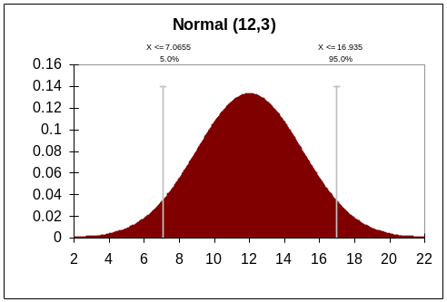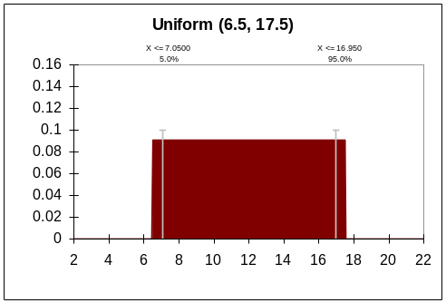
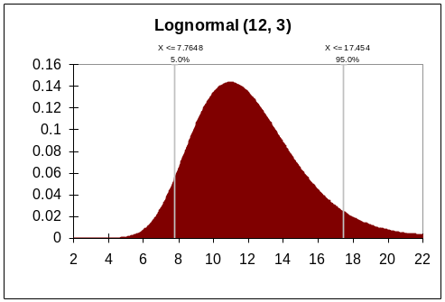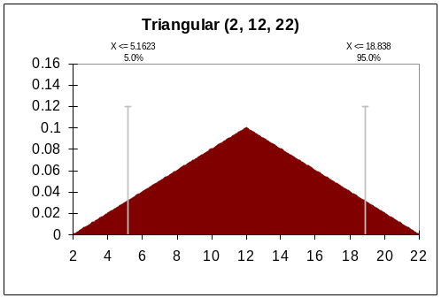
Figure 4. Normal, Uniform, Lognormal, and Triangular probability distributions.

Creating your own shape
Go to the Chart menu and select New. An initial blue shape along an x-axis will be displayed. The shape is defined by points connected to each other by lines. Each point is also linked to the x-axis by a vertical black line. You can alter the shape by moving or deleting existing points, or by adding new points. SpreadModel will standardize the PDF so that the area under the curve is always 1. If SpreadModel cannot standardize the curve, an error message will appear. (what should the user then do to solve the problem???) When done creating your new chart, go to the Chart menu and select Rename to title the chart, then go to the Chart menu, select Close, and click Yes to save your new chart.

Changing the x-axis
To increase the maximum value of the x-axis, click on the rightmost point of your distribution, and drag it towards the right. When you lift your finger from the mouse button, the x-axis will rescale. Similarly, to decrease the maximum value of the x-axis, click on the rightmost point of your distribution, and drag it to the left. The same techniques can be used to alter the minimum value visible on the x-axis.
The x-axis can be altered with more precision using the Edit all points option, described below.

Adding a new point
Move your pointer to a location on the chart where you would like an additional point. Right-click, then select Add point.

Moving an existing point
Click on the point you wish to move, and drag it to its new location. Or, if you know the precise x- and y-coordinates of the new location, right-click on the point you wish to move, select Edit point position, enter your x- and y-coordinates, and click OK.

Deleting an existing point
Right-click on the point you wish to delete, and select Remove point.

Edit all points
Go to the Chart menu and select Edit all points. A new window will open displaying the x- and y-coordinates of each point on the chart. If you wish to expand or contract the range of your x-axis, simply edit the x-coordinates of your first and last points to correspond with your minimum and maximum x-axis values. Click OK when done.

Exporting a pdf
You may want to export either the coordinates or image of a pdf. Exporting coordinates may be useful if you want to re-create the pdf in other software (e.g. Excel), or if you want to import the pdf for use in another variable (for example, you may want to use the same pdf for both latent and infectious subclinical periods). You can export the pdf to a file, or to the clipboard for pasting into another application.
To export to a file, go to the Export menu and choose To file. Select Points to save the x- and y-coordinates in a comma-delimited file (.csv). Select Chart image to save the chart in Windows metafile (.wmf) format.
To export (copy) to the clipboard, go to the Export menu and choose To clipboard. Select Points to copy the x- and y-coordinates in comma-delimited format, suitable for pasting into Excel or importing into another variable within SpreadModel. Select Chart image to copy the chart in Windows metafile format, suitable for pasting into Word or PowerPoint.

Printing a pdf
Go to the Export menu, and choose Chart image to printer.

Creating, modifying, and exporting a function (relationship)
A new relationship (rel) can be created by importing data or by using provided toolsto create your own. Relationships can be user-defined to take on any shape. Click on the Rel button to open the REL window.

Importing a relationship
Data should consist of two columns (x and y values) and should be in a comma-separated (.csv ) or tab-delimited file (.txt). X- and y-values should be in units appropriate for the relationship (for example, for a relationship describing vaccination capacity, the x-axis should be in days since the start of the outbreak, and the y-axis should be number of herds vaccinated per day). Data can be imported from a file or from the clipboard (after being copied from Excel, for example).
In the REL window, go to the Import menu and choose From file. Select your file, then click Open. To import data from the clipboard, go to the Import menu and choose From clipboard. Name your relationship by going to the Chart menu and choosing Rename. To save the relationship, go to the Chart menu and choose Close, then click Yes when you are asked to accept changes to the current chart.

Creating a new relationship
Go to the Chart menu and select New. A line of points with x- and y-axes will be displayed. You can alter the relationship by moving or deleting existing points, or by adding new points. When done creating your new relationship, go to the Chart menu and select Rename to title the chart, then go to the Chart menu, select Close, and click Yes to save your new chart.

Changing the x- and y-axes
To increase the maximum value of the x-axis, click on the rightmost point of your distribution, and drag it towards the right. When you lift your finger from the mouse button, the x-axis will rescale. Similarly, to decrease the maximum value of the x-axis, click on the rightmost point of your distribution, and drag it to the left. The same techniques can be used to alter the minimum value visible on the x-axis, and to alter the minimum and maximum values of the y-axis
Both axes can be altered with more precision using the Edit all points option, described below.
Note: If the y-axis is a proportion or probability, do not allow the maximum y-axis value to be greater than 1.

Adding a new point
Move your pointer to a location on the chart where you would like an additional point. Right-click, then select Add point.

Moving an existing point
Click on the point you wish to move, and drag it to its new location. Or, if you know the precise x- and y-coordinates of the new location, right-click on the point you wish to move, select Edit point position, enter your x- and y-coordinates, and click OK.

Deleting an existing point
Right-click on the point you wish to delete, and select Remove point.

Edit all points
Go to the Chart menu and select Edit all points. A new window will open displaying the x- and y-coordinates of each point on the chart. If you wish to expand or contract the range of your axes, simply edit the coordinates of your first and last points to correspond with your minimum and maximum x- amd y-axis values. Click OK when done.

Exporting a relationship
You may want to export either the coordinates or image of a relationship. Exporting coordinates may be useful if you want to re-create the relationship in other software (e.g. Excel), or if you want to import the relationship for use in another variable. You can export the relationship to a file, or to the clipboard for pasting into another application.
To export to a file, go to the Export menu and choose To file. Select Points to save the x- and y-coordinates in a comma-delimited file (.csv). Select Chart image to save the chart in Windows metafile (.wmf) format.
To export (copy) to the clipboard, go to the Export menu and choose To clipboard. Select Points to copy the x- and y-coordinates in comma-delimited format, suitable for pasting into Excel or importing into another variable within SpreadModel. Select Chart image to copy the chart in Windows metafile format, suitable for pasting into Word or PowerPoint.

Printing a relationship
Go to the Export menu, and choose Chart image to printer.

Structure (conceptual framework)

Basics
A collection of animals, called a “unit,” is the basis of the simulation. A unit has a production type, size, location, and disease state. The production type may be a single kind of livestock (e.g., “dairy cattle”) or a mixed type (e.g., “sheep and poultry”). Figure shows the states a unit may be in and possible transitions among them.

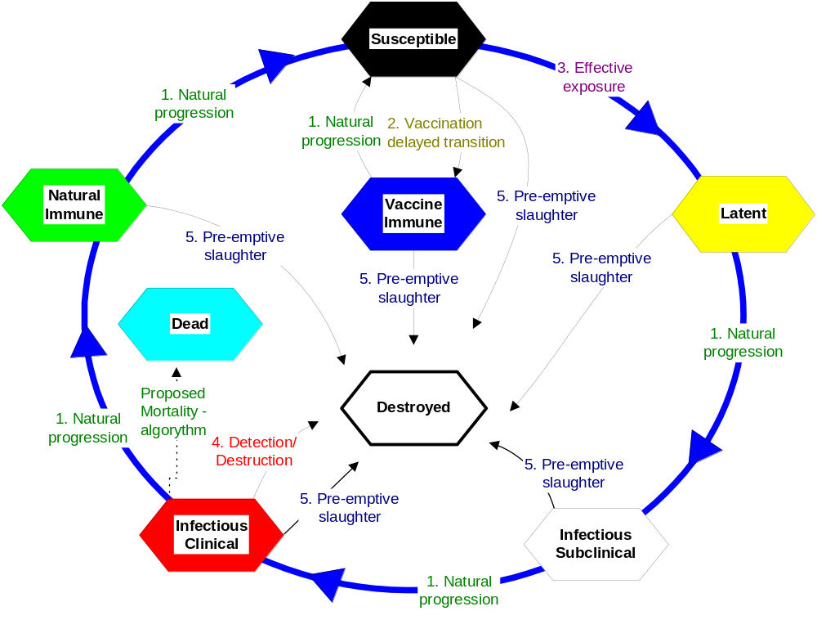
Figure 4. States and transitions

The simulation proceeds in time steps of one day. Each day units may be affected by biological processes happening in the animals (e.g., the natural progress of the disease), processes happening in the environment (e.g., airborne spread), and/or human actions (e.g., detection, vaccination, and destruction). The “model” is the sum of these processes and actions.

Disease
When a Susceptible unit is infected, it becomes Latent. The infection progresses in the unit from Latent to Infectious Subclinical (shedding agent without visible signs of disease), to Infectious Clinical (shedding agent with visible signs of disease), to Natural Immune, and back to the Susceptible state. Probability functions characterize the length of the periods and this length is determined stochastically for each new infection. The disease is never fatal, that is, all infected units will eventually return to Susceptible unless destroyed. If time-frames for simulations are long, a particular unit may progress through the infected states more than once.
A unit can spend zero time in a state. For example, the parameter for time spent as Infectious Subclinical can be zero. In that case, units will change directly from Latent to Infectious Clinical.
Attempting to infect a unit that is not Susceptible has no effect.
If two units are at the same location, infecting one does not automatically infect the other.
Parameters:
- latent period (days) 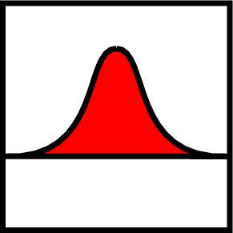
- infectious subclinical period (days)
- infectious clinical period (days)
- natural immune period (days)
The parameters are given separately for each production type. That is, the duration of the disease stages can be different for cattle, pigs, etc.

Spread

Direct contact spread
The simulation of direct contact – movement of animals among units – works as follows:
On each day,
- Look up a multiplier to adjust the rate of movement of animals based on the number of days since the first detection of the disease. Use this multiplier to scale the movement rate. This approximates applying movement-controls over the course of an infection spreading through the population of units.
- For each unit A,
  - Check whether A can be the source of an infection. That is, is it Latent, Infectious Subclinical, or Infectious Clinical, and not quarantined? (Infectious Clinical is always a source. Latent and Infectious Subclinical are optionally a source.)
  - If A cannot be a source, go on to the next unit.
  - Sample a number N from a Poisson distribution whose mean is the movement rate (adjusted by 1 above).
  - Create N shipments from A.
- For each shipment,
  - Sample a number, distance, from the movement distance distribution.
  - From all units that can be the target of disease-exposure (that is, those that are not Destroyed or are the source), choose the unit B whose distance from the source is closest to distance. If several possible targets are the same distance from the source, choose one randomly, giving preference to larger units (a unit with twice as many animals is twice as likely to be chosen).
  - If B is not Susceptible, the shipment has no effect on the disease state but is recorded as an exposure; go on to the next shipment.
  - Generate a random number r in [0,1), that is, from 0 up to but not including 1.
  - If r < P, the probability of infection given exposure, turn B Latent after a shipping delay.
The progress of the disease in the receiving unit starts at Latent, with the duration of each stage of the disease chosen stochastically, regardless of whether the shipping unit was Latent, Infectious Subclinical, or Infectious Clinical. A unit that receives Infectious Clinical animals could technically be regarded as immediately Infectious Clinical (able to infect other units by airborne spread and indirect contact, and detectable by a farmer or attending veterinarian) but starting the receiving herd at Latent reflects the fact that most of the animals in the receiving unit have to progress through the earlier disease-stages. The disease-state is an attribute of the unit as a whole rather than a direct reflection of the state of a particular animal in the unit.
Direct contacts (even ones that do not result in a new infection) are recorded and can be discovered later during trace-investigations.
The size of a shipment is not considered, and the number of animals in each unit does not change during the simulation.
The distance between 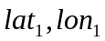 and 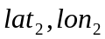 is approximated as:
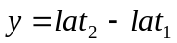
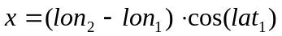
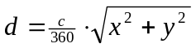
where c = the circumference of the earth.
Parameters:
- Mean rate of movement (recipient-units for shipments per source-unit per day)
- movement distance (km)
- shipping delay (days)
- probability of infection given exposure
- movement rate multiplier vs. days since the first detection 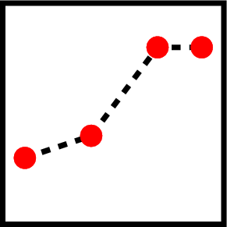
When more than one production-type is considered, the above parameters are specified for each pairing of one production-type with another. Consider the production-types “Beef” and “Dairy”, referring to herds of beef cattle and dairy cattle. You specify the most important pairings of these production-types with regard to direct-contact parameters. For example: “Beef” to “Beef”, “Beef” to “Dairy”, “Dairy” to “Beef”, and “Dairy” to “Dairy” are the possible pairings of these production-types. Separate parameters are specified for each of these pairs since the direct-contact among different production-type may vary.
Note that parameters are separate for movement in each direction between each pair of production-types. That is, the parameters for movement from “Beef” to “Dairy” can be different from the parameters for movement from “Dairy” to “Beef”, and the parameters for movement from “Beef” to say “Pigs” can be different again.
If parameters are given for movements from “Beef” to “Beef” and from “Beef” to “Dairy”, the number of shipments a “Beef” cattle herd A sends to “Beef” cattle herds on a particular day and the number of shipments A sends to “Dairy” cattle herds on the same day are independent.
Shipping animals from a Latent, Infectious Subclinical, or Infectious Clinical unit to a Natural Immune or Vaccine Immune unit has no effect on the disease-stage of the recipient unit. Shipping animals from a unit in a more advanced disease stage to a unit in a less advanced disease stage (e.g., from an Infectious Clinical unit to a Latent unit) also has no effect.

Indirect contact spread
Indirect contact – movement of people, materials, vehicles, equipment, animal products, etc among units – is simulated in the same manner as direct contact, except that only Infectious Subclinical and Infectious Clinical units, not Latent units, can be the source of infection. The parameters for indirect contact are similar to but independent of those for direct contact.
Indirect contacts can be discovered later during trace-investigations.

Airborne spread
The simulation of airborne spread works as follows:
On each day,
- For each unit A,
  - Check whether A can be the source of an infection. That is, is it Infectious Subclinical or Infectious Clinical?
  - If A cannot be a source, go on to the next unit.
  - For each other unit B,
    - Check whether B can be the target of an infection. That is, is it Suspectible, is the distance from A to B < the maximum distance of spread, and is the direction from A to B inside the wind direction range?
    - If B cannot be a target, go on to the next unit.
    - Compute the probability of infection P = probability of infection at 1 km × DistanceFactor(A,B) × HerdSizeFactor(A) × HerdSizeFactor(B).
    - Generate a random number r in [0,1).
    - If r < P, turn B Latent after a delay.
Where
DistanceFactor(A,B) = (maximum distance of spread - distance from A to B) / (maximum distance of spread - 1)
HerdSizeFactor(A) = (area under histogram of unit sizes from 0 to size of A) × 2
The distance between and is approximated as before. The direction from to is approximated with the inverse tangent using the same x and y.
Airborne spread can occur from and to quarantined units.
Airborne exposure is not recorded since it would not be used directly by mitigation processes such as movement-controls, vaccination, and destruction.
Parameters:
- probability of infection at 1 km from source (Infectious Subclinical or Infectious Clinical unit)
- wind direction, given as a range (start and end) in degrees
- maximum distance of spread (km)
- airborne transport delay (days)
The parameters are given separately for spread in each direction between each pair of production types. That is, the parameters for spread from pig herds to cattle herds can be different from the parameters for spread from cattle herds to pig herds, to account for potential differences in amount of virus produced and/or different minimum-infective-doses for animals in different production-types.

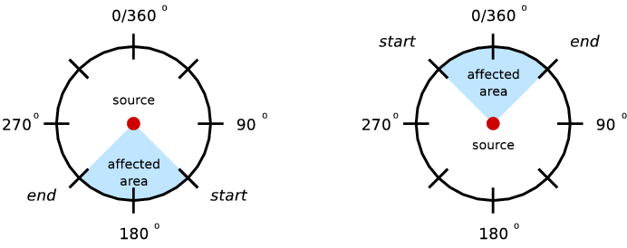
Figure 5. Example parameters for north winds (left) and south winds (right).

Detection
The simulation of detection works as follows:
On each day,
- Look up the probability that a farmer or attending veterinarian, for example, will report signs of disease to authorities based on the number of days since the first detection in the population. A static probability represents the baseline before the first detection.
- For each Infectious Clinical unit,
  - Look up the probability of detecting signs of disease based on the number of days the unit has been Infectious Clinical.
  - Compute the probability of detection and reporting (Equation 1 X 2a).
  - Generate a random number r in [0,1).
  - If r < P, the disease is detected and reported.
There are no false-positive detections.
A report is immediately known to the authorities.
Parameters:
- probability of reporting vs. days since the first detection
- probability of detection vs. days the unit has been Infectious Clinical
The parameters are given separately for each production type, to account for the possibility that signs of disease may be more obvious in animals of certain production-types, e.g., signs may be reported more rapidly in intensive swine production systems versus cow-calf operations on pastures.

Control measures

Quarantine
A diseased unit is quarantined as soon as it is detected. Quarantined units cannot be involved in direct contact, but indirect contact and airborne spread may still occur to or from a quarantined unit.

Destruction
When the first detection happens in the study population, the authorities may initiate a destruction program. It can take several days before the authorities are ready to begin destroying.
All detected units are marked for destruction. Units that have had contact with diseased units within a given number of days prior to detection of the diseased unit (found through trace-investigations) and units within a given distance of diseased units may also be marked for destruction. The destruction of these units associated by trace or distance has been called pre-emptive or dangerous-contact slaughter.
Trace-investigations are immediate. Tracing goes one level forward, that is, it identifies units that have had recent contact with a diseased unit, but not units that have had contact with units that have had contact with a diseased unit, and so on (Figure ).
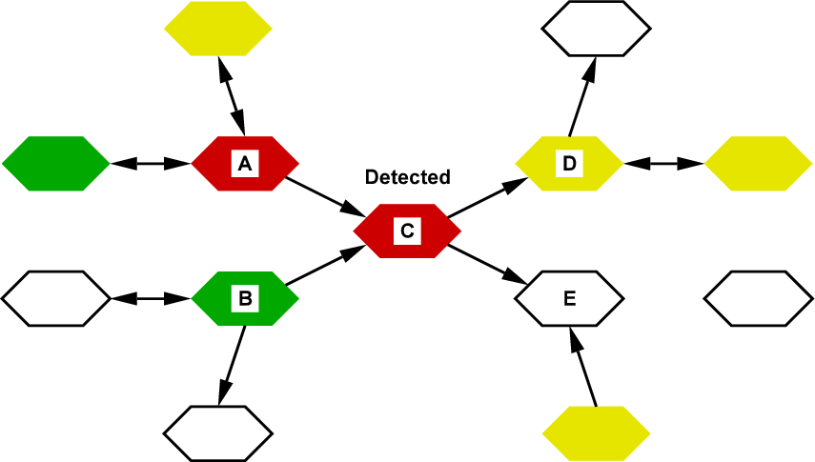

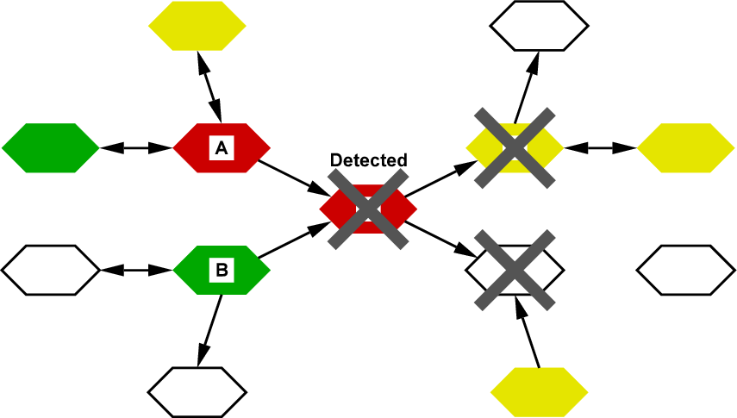
Figure 6. Trace out. When unit C is detected, units to which C has shipped animals or sent people or equipment are marked for destruction. The trace does not extend further (e.g., to units that shipped animals to C, or units that received animals from D).
There is a limit (called Capacity) on how many units can be destroyed per day. If a unit is marked for destruction but cannot be destroyed immediately, it is quarantined and goes onto a prioritized waiting list.
The priorities are set according to production-type, reason for destruction and the number of days already holding for destruction. For example, cattle herds that are marked for destruction because they were detected as diseased may have a higher priority than cattle herds that are marked for destruction because they are near a diseased unit, and pig herds may have a higher priority still.
No two production-type/reason for destruction combinations can have the same priority. That is, cattle herds that were detected as diseased must have a strictly higher priority than pig herds that were detected as diseased (or vice versa), and cattle herds that were detected as diseased must have a strictly higher priority than cattle herds that were simply near to a detected unit (or vice versa).
On each day, the authorities destroy as many units as possible (up to the limit) from the waiting list beginning with the highest priority.
Parameters:
- delay to begin a destruction program (days)
- destruction capacity vs. days since the first detection (units per day)
- probability of a trace-out investigation succeeding
- period of interest for trace-out investigations (days)
- radius of destruction ring (km)
The parameters are given separately for each production type.

Vaccination
When the disease is detected, authorities may also initiate a vaccination campaign. This consists of vaccinating units within a specified distance of the detected units – in circles or rings around detected units. The decision to vaccinate may be delayed until a certain trigger point is reached in terms of numbers of detected units.
Vaccination orders result in vaccination unless the herd has already been vaccinated recently.
If a unit is marked for vaccination but cannot be vaccinated immediately, it goes onto a prioritized waiting list, which is managed the same way as the waiting list for destruction.
Personnel for destruction cannot be temporarily loaned to vaccination teams, or vice versa, during a simulation run. In other words, the daily limits for destroying and vaccinating operate independently of each other and other production-types as well.
Parameters:
- number of detected units before vaccination begins
- vaccination capacity vs. days since the first detection (units per day )
- radius of vaccination ring (km)
- minimum time between vaccinations (days)
The parameters are given separately for each production type.

Vaccine
When a unit is vaccinated, it remains Susceptible for a time while immunity develops, then becomes Vaccine Immune. The length of the immunity period is decided stochastically for each new vaccination. After the immunity period, the unit reverts to Susceptible.
If a unit is infected after being vaccinated but before turning Vaccine Immune, the effects of the vaccination are cancelled.
Vaccinating a unit that is not Susceptible has no effect on its disease state.
Parameters:
- delay to produce immunity (days)
- immunity period (days)
The parameters are given separately for each production type.

Priorities of action
Because the events in one simulation day should be considered to happen simultaneously, and because different processes may try to make conflicting changes to a unit, there is a need to order or prioritize the processes.
The ordering is:
- Infection, vaccination, or destruction
- Biological processes happening inside the animals
(Note that these correspond to the transition labels in Figure .)
If a unit is both infected and vaccinated, infected and destroyed, vaccinated and destroyed, or all three on the same day, the order in which these happen is chosen randomly.
If two or more processes infect the same unit on the same day, one process is chosen randomly as the cause of the infection, for the purpose of reporting in simulation statistics. Similarly, if there are two or more reasons for vaccinating or destroying a unit, one reason is chosen randomly for the purpose of reporting.
Some examples illustrating the effects of this ordering:
- If unit A is due to change from Susceptible to Vaccine Immune on day D, and a shipment of infectious animals arrives on day D, A is infected. (The exposure happens “before” the natural progression to Vaccine Immune.)
- If unit A is due to change from Vaccine Immune to Susceptible on day D, and the wind carries virus from an infectious unit on day D, A is not infected. (The exposure happens “before” the natural progression to Susceptible.)
- If unit A is destroyed on day D, and the wind carries virus from an infectious unit on day D, A may be reported in simulation statistics as having been an infected unit or a healthy unit. (Whether the infection happens “before” the destruction is determined randomly.)

Additional topics I’d like to get to, but haven’t yet…

Use as a training tool
Using your own data
Parameters needed (i.e. herd sizes, locations, production types, etc.)
Format for import (i.e. MS Access, variable names, etc.)
Disease parameters (disease stages)
Transmission parameters (aerosol, contact rates)
Disease detection options
Disease control options
Spreadmodel outputs
Statistical analysis
Interpretation
FAQs
All my iterations have identical results
No disease outbreak develops
Out of memory error
Infected herds are not destroyed or vaccinated
Index

indicates a parameter that is given as a probability function.
see section Control measures for a description of quarantine.
fixed at 24-48 hours in SpreadModel v3.0.
indicates a parameter that is given as a relational chart.
see section Control measures for a description of quarantine.
fixed at 0-24 hours in SpreadModel v3.0.

